NEHRU SCIENCE CENTRE
(National Council of Science Museums)
Ministry of Culture, Govt. of India
Dr. E Moses Road, Worli, Mumbai - 400018
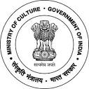
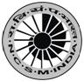
Telephone: 022-24932667 www.nehrusciencecentre.gov.in
Notice Inviting E-Tender No. NSCM/18012/207/2021

E-Tenders are invited for the following works:

Sr.No | Tender ID | Name of the work | Estimated Cost
01 | 2021_NCSM_646765_1 | Interior, Furniture and Allied works of Innovation Hub at Science Innovation & Activity Centre, Baramati | Rs.18,45,565/-

Please visit website http://eprocure.gov.in/eprocure/app and search with Tender ID mentioned above for details & online tendering. Tenders may be submitted between 13.09.2021 and 04.10.2021. Advt.No. /2021

